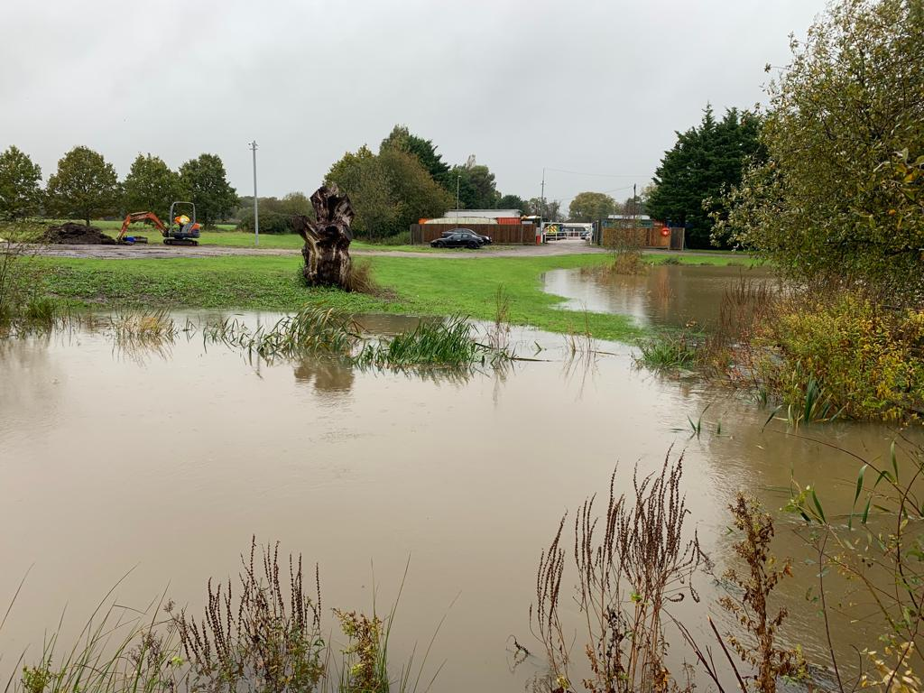
Oakendene in November.

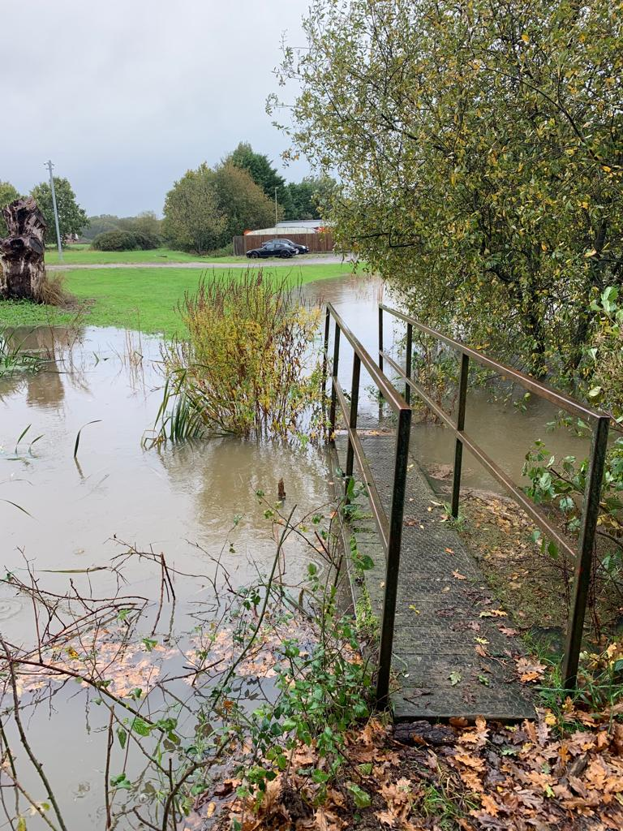

Western end of Oakendene Lake

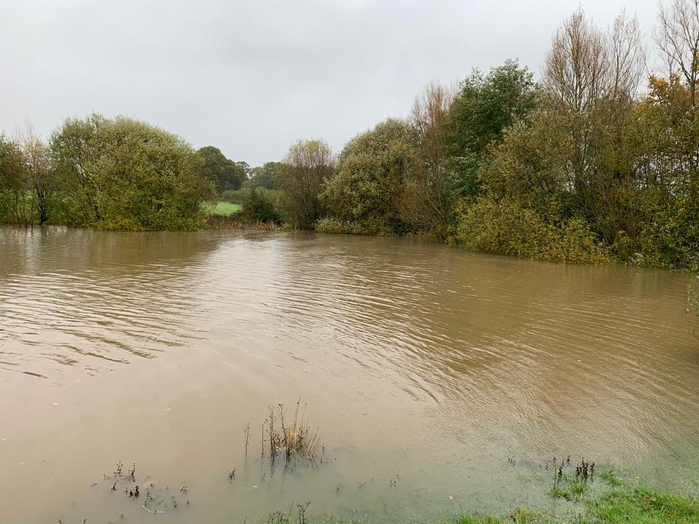
Oakendene Lake
Footbridge to west of Oakendene Lake

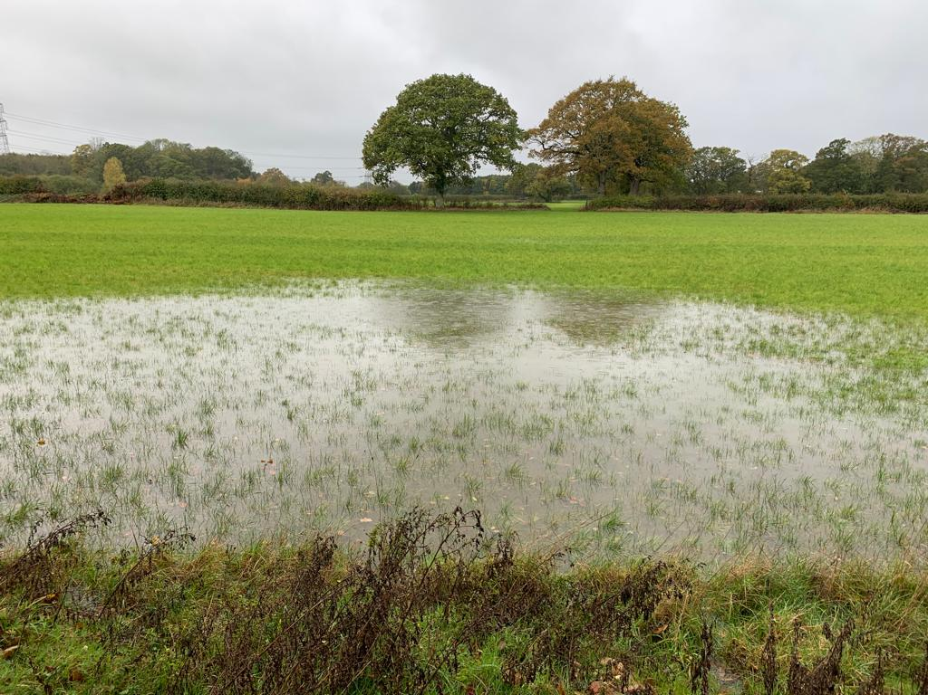

Southern end of Proposed Substation Site from the south
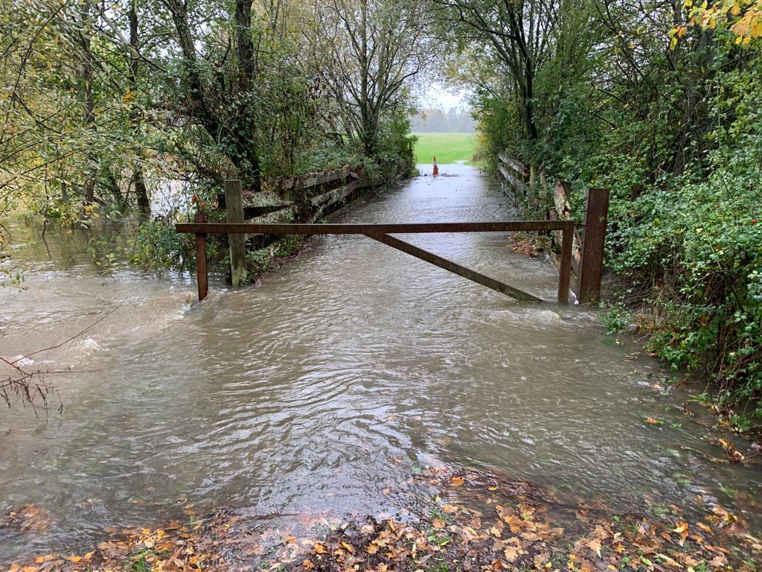
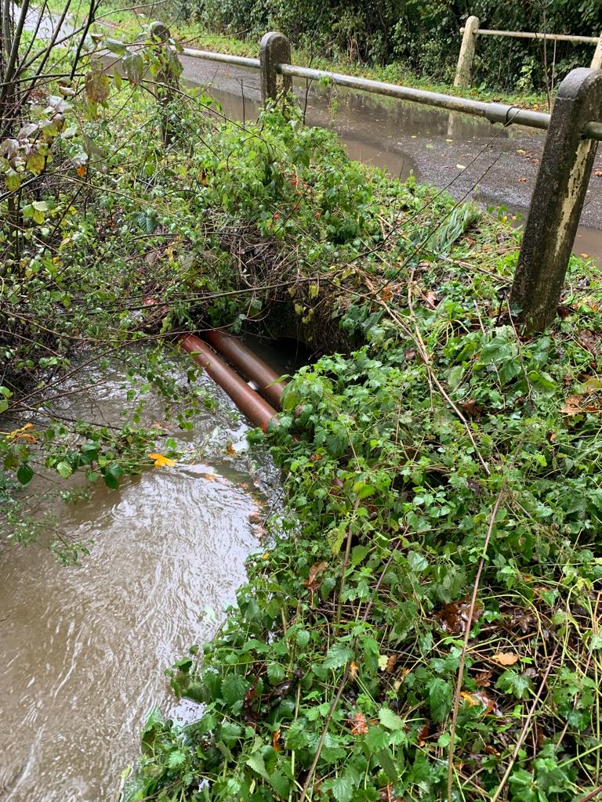
Cowfold Stream tributary under Kent Street

Public Right of Way #1786

